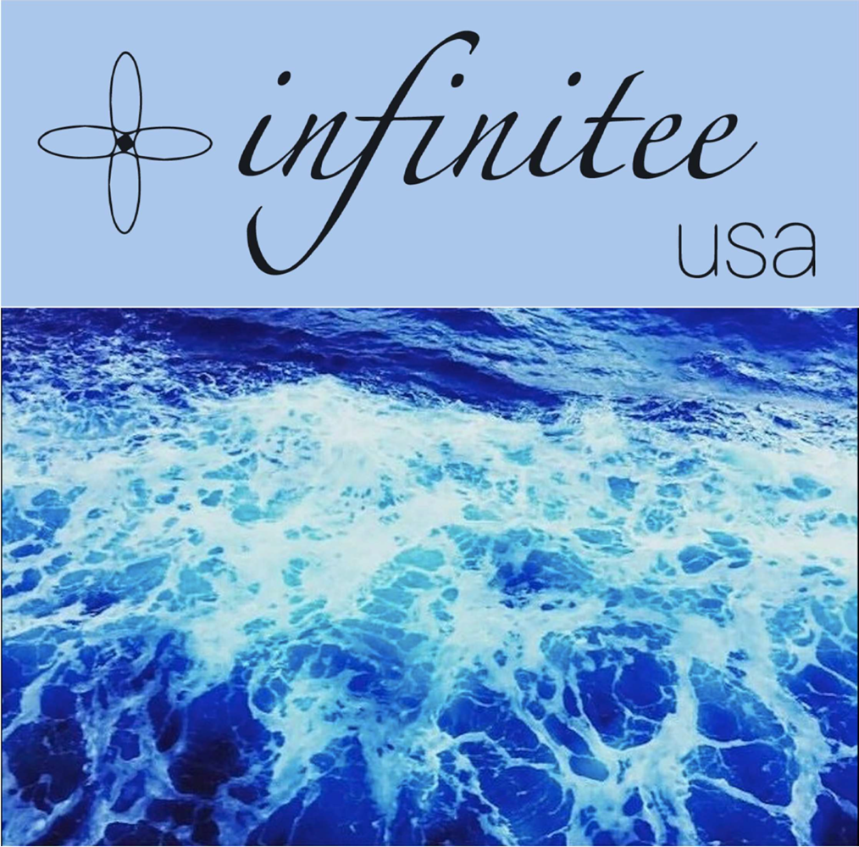

**Power Your Business With Our**

**Naturals & Synthetics**

**ABOUT INFINITEE USA**

**INFINITEE USA, an ISO 9001:2015, Vegan and RSPO certified company, is in the business of providing specialty natural & synthetic ingredients primarily for the Personal Care industry for North & South American markets as well as Europe. Based out of New Jersey, INFINITEE USA, is a member of the Global Shea Alliance. The flagship company of the multinational INFINITEE group, INFINITEE USA has international industry knowledge and a global network of suppliers and customers. At the forefront of innovation, INFINITEE USA brings you high-quality cutting-edge products like actives & probiotics that can add value to your next formulation**

**PERSONAL CARE**



**CARE**

|  |  |  |
| --- | --- | --- |
| **ACTIVES & SPECIALTIES** | | |
| **INFIN Allantoin** | **Allantoin** | |
| **INFIN Niacinamide** | **Niacinamide** | |
| **INFIN Rejuve ADE** | **Adenosine** | |
| **INFIN Moist Beat** | **Betaine** | |
| **INFIN Moist ECT** | **Ectoin** | |
| **INFIN Moist Hyal H** | **Hyaluronic Acid (High Molecular Weight)** | |
| **INFIN Moist Hyal L** | **Hyaluronic Acid (Low Molecular Weight)** | |
| **INFIN Moist HEU** | **Hydroxyethyl Urea** | |
| **INFIN Moist PSO** | **Phytosteryl Oleate** | |
| **INFIN Slim CARN** | **Carnitine** | |
| **INFIN Slim VBE** | **Vanillyl Butyl Ether** | |
| **INFIN White Alpha-ABT** | **Alpha Arbutin** | |
| **INFIN White Beta-ABT** | **Beta Arbutin** | |
| **INFIN White VC-IP** | **Ascorbyl Tetraisopalmitate** | |
| **INFIN White VCE** | **Ethyl Ascorbic Acid** | |
| **INFIN White KDP** | **Kojic Dipalmitate** | |
| **INFIN White TA** | **Tranexamic Acid** | |
| **SUNSCREENS** | | |
| **INFIN Sun AVO** | **Avobenzone** | |
| **INFIN Sun Benz 3** | **Benzophenone-3** | |
| **INFIN Sun Benz 4** | **Benzophenone-4** | |
| **INFIN Sun EHT** | **Ethylhexyl Triazone** | |
| **INFIN Sun HS** | **Homosalate** | |
| **INFIN Sun OS** | **Octisalate** | |
| **INFIN Sun OCR** | **Octocrylene** | |
| **INFIN Sun OMC** | **Octyl Methoxycinnamate** | |
| **NATURALS** | | |
| **PLANT BASED OILS** | | |
| **INFIN Oil Almond Sweet (R)** | | **Refined Sweet Almond Oil** |
| **INFIN Oil Apricot** | | **Apricot Oil** |
| **INFIN Oil Argan** | | **Argan Oil** |
| **INFIN Oil Avocado** | | **Avocado Oil** |
| **INFIN Oil Bergamot** | | **Bergamot Oil** |
| **INFIN Oil Black Seed** | | **Black Seed Oil** |
| **INFIN Oil Borage** | | **Borage Oil** |
| **INFIN Oil Canola** | | **Refined Canola Oil** |
| **INFIN Oil Castor Black** | | **Black Castor Oil** |
| **PLANT BASED OILS**  **PERSONAL CARE**    **CARE** | | |
| **INFIN Oil Castor CP** | | **Castor Oil Cold Pressed** |
| **INFIN Oil Castor FSG** | | **Castor Oil First Special Grade** |
| **INFIN Oil HCO** | | **Castor Oil Hydrogenated** |
| **INFIN Oil CBD 1** | | **CBD Oil 1** |
| **INFIN Oil CBD 2** | | **CBD Oil 2** |
| **INFIN Oil CBD 5** | | **CBD Oil 5** |
| **INFIN Oil Citronella** | | **Citronella Oil** |
| **INFIN Oil Clove** | | **Clove Oil** |
| **INFIN Oil Coconut (EV)** | | **Extra Virgin Coconut Oil** |
| **INFIN Oil Coconut (R)** | | **Refined Coconut Oil 76°** |
| **INFIN Oil Corn** | | **Refined Corn Oil** |
| **INFIN Oil Eucalyptus** | | **Eucalyptus Oil** |
| **INFIN Oil Flaxseed** | | **Refined Flaxseed Oil** |
| **INFIN Oil Grapefruit Pink** | | **Grapefruit Oil Pink** |
| **INFIN Oil Grapeseed** | | **Grapeseed Oil** |
| **INFIN Oil Hemp** | | **Hemp Seed Oil** |
| **INFIN Oil Hemp (R)** | | **Refined Hemp Seed Oil** |
| **INFIN Oil Jojoba Golden** | | **Jojoba Golden Oil** |
| **INFIN Oil Jojoba** | | **Jojoba Oil Colorless** |
| **INFIN Oil Karanja** | | **Karanja Oil** |
| **INFIN Oil Lemon** | | **Lemon Oil** |
| **INFIN Oil Lemongrass** | | **Lemongrass Oil** |
| **INFIN Oil Lime** | | **Lime Oil** |
| **INFIN Oil Macadamia** | | **Macadamia Oil** |
| **INFIN Oil MCT 60/40 P** | | **Medium Chain Triglycerides Oil 60/40 Palm based (CCTG)** |
| **INFIN Oil MCT 60/40 C** | | **Medium Chain Triglycerides Oil 60/40 Coconut based (CCTG)** |
| **INFIN Oil MCT 70/30 P** | | **Medium Chain Triglycerides Oil 70/30 Palm based (CCTG)** |
| **INFIN Oil MCT 70/30 C** | | **Medium Chain Triglycerides Oil 70/30 Coconut based (CCTG)** |
| **INFIN Oil Moringa** | | **Moringa Oil** |
| **INFIN Oil Neem** | | **Neem Oil** |
| **INFIN Oil Olive (R)** | | **Refined Olive Oil** |
| **INFIN Oil Olive (EV)** | | **Extra Virgin Olive Oil** |
| **INFIN Oil Olive Pomace** | | **Pomace Olive Oil** |
| **INFIN Oil Palm** | | **Refined Palm Oil** |
| **INFIN Oil Palm Kernel** | | **Refined Palm Kernel Oil** |
| **INFIN Oil Peanut** | | **Refined Peanut Oil** |
| **INFIN Oil Peppermint** | | **Peppermint Oil** |
| **INFIN Oil Pomegranate** | | **Pomegranate Oil** |
| **INFIN Oil Pomifera** | | **Pomifera Oil** |
| **INFIN Oil Raspberry** | | **Raspberry Oil** |
| **INFIN Oil Rice Bran** | | **Refined Rice Bran Oil** |
| **INFIN Oil Rosehip** | | **Rosehip Oil** |
| **INFIN Oil Rosemary** | | **Rosemary Oil** |
| **INFIN Oil Rosewood** | | **Rosewood Oil** |
| **INFIN Oil Safflower** | | **Refined Safflower Oil** |
| **INFIN Oil Safflower HO** | | **Refined High Oleic Safflower Oil** |
| **INFIN Oil Sandalwood** | | **Sandalwood Oil** |
| **INFIN Oil Sea Buckthorn** | | **Sea Buckthorn Oil** |
| **INFIN Oil Sesame** | | **Refined Sesame Oil** |
| **INFIN Oil Shea** | | **Shea Oil** |
| **INFIN Oil Soybean** | | **Refined Soybean Oil** |
| **PLANT BASED OILS**  **PERSONAL CARE**    **CARE** | | |
| **INFIN Oil Soybean HO** | | **Refined High Oleic Soybean Oil** |
| **INFIN Oil Sunflower MO** | | **Refined Mid Oleic Sunflower Oil** |
| **INFIN Oil Sunflower HO** | | **Refined High Oleic Sunflower Oil** |
| **INFIN Oil Sunflower LO** | | **Refined Linoleic Sunflower Oil** |
| **INFIN Oil Tamanu** | | **Tamanu Oil** |
| **INFIN Oil Tea Tree** | | **Tea Tree Oil** |
| **INFIN Oil Tung** | | **Tung Oil** |
| **INFIN Oil Umutanga** | | **Umutanga Oil** |
| **BUTTERS & WAXES** | | |
| **INFIN Butter Aloe** | | **Aloe Butter** |
| **INFIN Butter Avocado** | | **Avocado Butter** |
| **INFIN Butter CBD 1** | | **CBD Butter 1** |
| **INFIN Butter CBD 5** | | **CBD Butter 5** |
| **INFIN Butter Cocoa** | | **Cocoa Butter** |
| **INFIN Butter Coconut** | | **Coconut Butter** |
| **INFIN Butter Illipe** | | **Illipe Butter** |
| **INFIN Butter Kokum** | | **Kokum Butter** |
| **INFIN Butter Lime** | | **Lime Butter** |
| **INFIN Butter Mango** | | **Mango Butter** |
| **INFIN Butter Olive** | | **Olive Butter** |
| **INFIN Butter Palm Kernel** | | **Palm Kernel Butter** |
| **INFIN Butter Sal** | | **Sal Butter** |
| **INFIN Butter Shea** | | **Refined Shea Butter** |
| **INFIN Butter Sunflower** | | **Sunflower Butter** |
| **INFIN Carnauba Wax** | | **Carnauba Wax** |
| **INFIN Soy Wax** | | **Soy Wax** |
| **INFIN White Beeswax** | | **White Beeswax** |
| **INFIN Yellow Beeswax** | | **Yellow Beeswax** |
| **ORGANIC INGREDIENTS** | | |
| **INFIN Butter Organic Cocoa** | | **Organic Cocoa Butter** |
| **INFIN Butter Organic Shea** | | **Organic Refined Shea Butter** |
| **INFIN Oil Organic Argan** | | **Organic Argan Oil** |
| **INFIN Oil Organic Avocado** | | **Organic Avocado Oil** |
| **INFIN Oil Organic CBD 1** | | **Organic CBD Oil 1** |
| **INFIN Oil Organic CBD 2** | | **Organic CBD Oil 2** |
| **INFIN Oil Organic CBD 5** | | **Organic CBD Oil 5** |
| **INFIN Oil Organic Coconut (EV)** | | **Organic Extra Virgin Coconut Oil** |
| **INFIN Oil Organic Coconut (R)** | | **Organic Refined Coconut Oil** |
| **INFIN Oil Organic Hemp** | | **Organic Hemp Seed Oil** |
| **INFIN Oil Organic Jojoba Golden** | | **Organic Jojoba Golden Oil** |
| **INFIN Oil Organic Olive (EV)** | | **Organic Extra Virgin Olive Oil** |
| **INFIN Oil Organic Palm Kernel** | | **Organic Palm Kernel Oil** |
| **INFIN Oil Organic Pomegranate** | | **Organic Pomegranate Oil** |
| **INFIN Oil Organic Raspberry** | | **Organic Raspberry Oil** |
| **INFIN Oil Organic Rosehip** | | **Organic Rosehip Oil** |
| **INFIN Oil Organic Rosemary** | | **Organic Rosemary Oil** |
| **INFIN Oil Organic Soybean (R)** | | **Organic Refined Soybean Oil** |
| **INFIN Oil Organic Sunflower** | | **Organic Sunflower Oil** |
| **INFIN Oil Organic Sunflower HO** | | **Organic High Oleic Sunflower Oil** |
| **ORGANIC INGREDIENTS**  **PERSONAL CARE** | | |
| **INFIN Organic Carnauba Wax** | | **Organic Carnauba Wax** |
| **INFIN Organic White Beeswax** | | **Organic White Beeswax** |
| **INFIN Organic Soy Glycerin** | | **Organic Soy Glycerin** |
| **SYNTHETICS** | | |
| **EMULSIFYING WAXES** | | |
| **INFIN EW 100** | | **Cetostearyl Alcohol with Alcohols, C16-18, Ethoxylated** |
| **INFIN EW 200** | | **Cetostearyl Alcohol with Sodium Dodecyl Sulfate** |
| **INFIN EW 300** | | **Cetostearyl Alcohol with Polyoxyethylene Sorbitan Monostearate** |
| **INFIN EW 400** | | **Cetostearyl Alcohol with Isopropyl Tetradecanoate, Ceteareth 22, and Caprylic Capric Triglyceride** |
| **ESTERS** | | |
| **INFIN Ester IPM** | | **Isopropyl Myristate** |
| **INFIN Ester IPP** | | **Isopropyl Palmitate** |
| **INFIN Ester OP** | | **Octyl Palmitate** |
| **PRESERVATIVES** | | |
| **INFIN Guard CG** | | **Caprylyl Glycol** |
| **INFIN Guard DMDMH** | | **1,3-Dimethylol-5,5-Dimethyl Hydantoin** |
| **INFIN Guard EHG** | | **Ethylhexyl Glycerin** |
| **INFIN Guard PE P5** | | **Phenoxyethanol (free phenol < 5 ppm)** |
| **INFIN Guard PE PR** | | **Phenoxyethanol (free phenol < 150 ppm)** |
| **INFIN Guard PEEHG** | | **Phenoxyethanol and Ethylhexyl Glycerin** |
| **CASTOR OIL DERIVATIVES** | | |
| **INFIN Oil Castor Sulfonated** | | **Sulfonated Castor Oil** |
| **INFIN Surf HCO ET 36** | | **PEG-36 Hydrogenated Castor Oil** |
| **INFIN Surf HCO ET 40** | | **PEG-40 Hydrogenated Castor Oil** |
| **INFIN Surf HCO ET 60** | | **PEG-60 Hydrogenated Castor Oil** |
| **GMS (GLYCERYL MONOSTEARATE) – VEGETABLE EMULSIFIERS** | | |
| **INFIN Surf GMS** | | **Glyceryl Monostearate** |
| **INFIN Surf GMS LG** | | **Glyceryl Monostearate, Low Glycerin** |
| **INFIN Surf GMS SE** | | **Glyceryl Monostearate, Self-Emulsifying** |
| **INFIN Surf GMS 165** | | **Glyceryl Monostearate & PEG 100 Stearate** |
| **RHEOLOGY MODIFIERS** | | |
| **INFIN Poly 7** | | **Polyquaternium 7** |
| **INFIN Poly 10** | | **Polyquaternium 10** |
| **INFIN Poly 11** | | **Polyquaternium 11** |
| **INFIN Poly 934** | | **Carbomer 934** |
| **INFIN Poly 940** | | **Carbomer 940** |
| **INFIN Poly 980** | | **Carbomer 980** |
| **INFIN Poly A 21** | | **Acrylates / C10-30 Alkyl Acrylate Crosspolymer** |
| **INFIN Poly Aqua SF 1** | | **Acrylates Copolymer** |
| **INFIN Poly ELT 10** | | **Carbomer ELT 10** |
| **INFIN Poly ET 2020** | | **Acrylates / C10-30 Alkyl Acrylate Crosspolymer** |
| **SURFACTANTS** | | |
| **INFIN Surf AOS Liquid** | | **Alfa Olefin Sulfonate Liquid** |
| **INFIN Surf AOS Powder** | | **Alfa Olefin Sulfonate Powder** |
| **INFIN Surf APG CG** | | **Coco Glucoside** |
| **SURFACTANTS**  **PERSONAL CARE** | | |
| **INFIN Surf APG DG** | | **Decyl Glucoside** |
| **INFIN Surf APG LG** | | **Lauryl Glucoside** |
| **INFIN Surf BTMC** | | **Behentrimonium Chloride** |
| **INFIN Surf BTMS 25** | | **Behentrimonium Methosulfate and Cetearyl Alcohol** |
| **INFIN Surf BTMS 50** | | **Behentrimonium Methosulfate and Cetearyl Alcohol** |
| **INFIN Surf CAPB** | | **Cocamidopropyl Betaine** |
| **INFIN Surf CAPHS** | | **Cocamidopropyl Hydroxysultaine** |
| **INFIN Surf EGDS** | | **Ethylene Glycol Distearate** |
| **INFIN Surf EGMS** | | **Ethylene Glycol Monostearate** |
| **INFIN Surf LABSA** | | **Linear Alkylbenzene Sulfonic Acid** |
| **INFIN Surf LAO** | | **Lauryl Amine Oxide** |
| **INFIN Surf Laureth 3** | | **Laureth 3** |
| **INFIN Surf Laureth 4** | | **Laureth 4** |
| **INFIN Surf Laureth 7** | | **Laureth 7** |
| **INFIN Surf Laureth 9** | | **Laureth 9** |
| **INFIN Surf NP 9** | | **Nonylphenol Ethoxylate** |
| **INFIN Surf Polysorbate 20** | | **Polysorbate 20** |
| **INFIN Surf Polysorbate 80** | | **Polysorbate 80** |
| **INFIN Surf SCG P** | | **Sodium Cocoyl Glycinate** |
| **INFIN Surf SCI 85** | | **Sodium Cocoyl Isethionate 85** |
| **INFIN Surf SLI 80** | | **Sodium Lauroyl Isethionate 80** |
| **INFIN Surf SCT 30** | | **Sodium Cocoyl Methyltaurate 30** |
| **INFIN Surf SLES 28** | | **Sodium Lauryl Ether Sulfate 28** |
| **INFIN Surf SLES 70** | | **Sodium Lauryl Ether Sulfate 70** |
| **INFIN Surf SCS N** | | **Sodium Coco Sulfate Needles** |
| **INFIN Surf SLS L / G / N / P** | | **Sodium Lauryl Sulfate Liquid/ Granules/ Needles/ Powder** |
| **INFIN Surf SLSA** | | **Sodium Lauryl Sulfoacetate** |
| **INFIN Surf SLSC** | | **Sodium Lauroyl Sarcosinate** |
| **FATTY ALCOHOLS** | | |
| **INFIN Alcohol Behenyl** | | **Behenyl Alcohol** |
| **INFIN Alcohol Cetearyl 1618 TA** | | **Cetearyl Alcohol 1618 TA (30/70)** |
| **INFIN Alcohol Cetearyl 1618 (50/50)** | | **Cetearyl Alcohol 1618 (50/50)** |
| **INFIN Alcohol Cetyl 1698** | | **Cetyl Alcohol 1698** |
| **INFIN Alcohol Stearyl 1898** | | **Stearyl Alcohol 1898** |
| **LANOLINS** | | |
| **INFIN Alcohol Lanolin** | | **Lanolin Alcohol** |
| **INFIN Oil Lanolin** | | **Lanolin Oil** |
| **INFIN Lanolin Wax** | | **Lanolin Wax** |
| **ASSORTED INGREDIENTS** | | |
| **INFIN Alkyl Benzoate C12-C15** | | **Alkyl Benzoate C12-C15** |
| **INFIN Aloe Vera 1X** | | **Aloe Vera Gel** |
| **INFIN Aloe Vera Powder** | | **Aloe Vera Powder** |
| **INFIN Aloe Vera Powder 200X SD** | | **Aloe Vera Powder 200X Spray Dried** |
| **INFIN Citric Acid** | | **Citric Acid** |
| **INFIN D-Panthenol** | | **D-Panthenol** |
| **INFIN DL-Panthenol** | | **DL-Panthenol** |
| **INFIN DMAPA** | | **Dimethylaminopropylamine** |
| **INFIN Ferulic Acid** | | **Ferulic Acid** |
| **INFIN Glycerin C** | | **Glycerin Coconut based** |
| **ASSORTED INGREDIENTS** | | |
| **INFIN Glycerin P** | | **Glycerin Palm based** |
| **INFIN Green Tea Extract (Liquid)** | | **Green Tea Liquid Extract** |
| **INFIN Oil Mineral** | | **Mineral Oil** |
| **INFIN PEIB** | | **Phenoxyethyl Isobutyrate** |
| **INFIN Rosehip Powder** | | **Rosehip Powder** |
| **INFIN SMCA** | | **Sodium Monochloroacetate** |
| **INFIN Squalane Olive** | | **Olive Squalane** |
| **INFIN Stearic Acid** | | **Stearic Acid – Triple Pressed** |
| **INFIN Tan DHA** | | **Dihydroxyacetone** |
| **INFIN Vitamin E Acetate** | | **Vitamin E Acetate / Tocopherol Acetate** |
| **PROBIOTICS** | | |
| **SKIN & HAIR CARE** | | |
| **INFIN Probiotic Bioderm 20X (L)** | | **Exfoliates & Brightens Skin**  **Smooths & Evens Skin Tone**  **Improves Skin & Scalp Microbiome**  **Eliminates Odor** |
| **INFIN Probiotic Bioderm 100B (P)** | |
| **HOME CARE** | | |
| **INFIN Probiotic Home OS 10X (L)** | | **Antibacterial, Disinfectant**  **Odor Eliminator**  **Stain Remover** |
| **INFIN Probiotic Home OS 20X (L)** | |
| **INFIN Probiotic Home HINI 100B (P)** | |
| **OUR CERTIFICATIONS** | | |
|  | | |

**PERSONAL CARE**



**CARE**



GLOBAL HEADQUARTERS

**INFINITEE USA**

**1 Tristas Way**

**South Plainfield, NJ 07080 Ph:+1 (908) 561-2757**

[**info@infiniteeusa.com**](mailto:info@infiniteeusa.com)

**Visit us at**

[**www.infiniteeusa.com**](http://www.infiniteeusa.com)

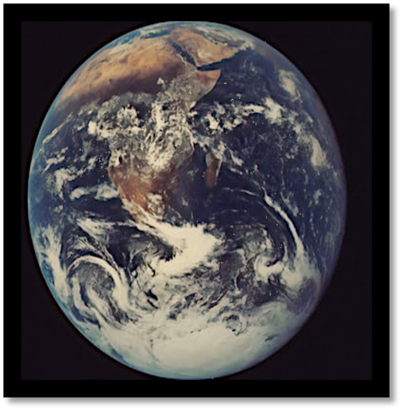

**Mar 18, 2024**